Practical - 2

Practical Title: Semantic HTML5 Pages with Accessibility-Ready Structure
Problem Definition: Develop static HTML5 skeletons for at least 10 StudentHub pages such as Home, About, Register, Login, Dashboard, Events, Profile, Contact, Admin, FAQ, and Feedback. Use semantic tags and accessibility-friendly structure.

Theory
  - Are semantic tags such as header, nav, main, section, article, aside, and footer used properly?
Answer: Yes, I used semantic tags like <header>, <nav>, <main>, <section>,
<aside>, and <footer> properly to organize the webpage.

  - Are form labels, headings, image alt text, and navigation links accessible? Answer: Yes, all form labels, headings, image alt text, and navigation links are accessible.

  - Is the page structure consistent across all pages?
Answer: Yes, all pages have a consistent layout, navigation, and design.

Evidence of Work (Screenshots)

index.html :

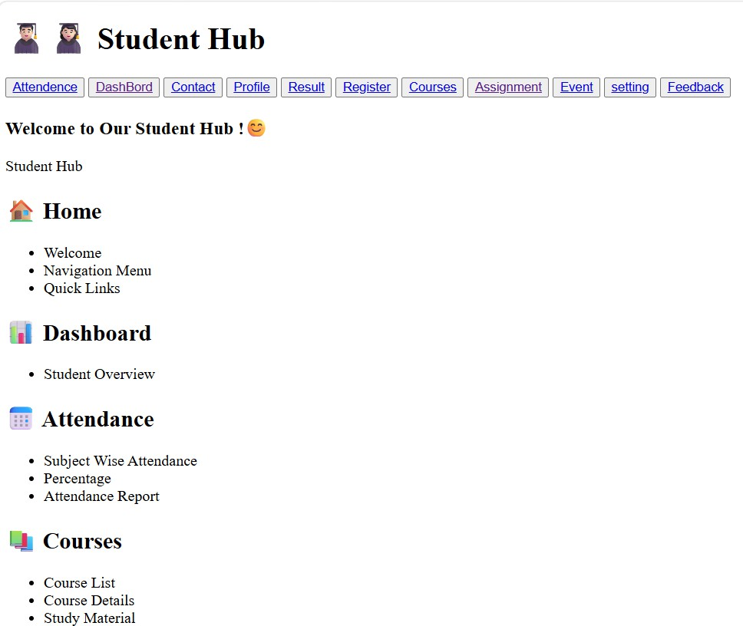
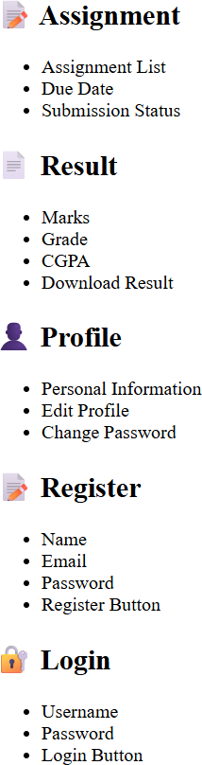

Attedance.html
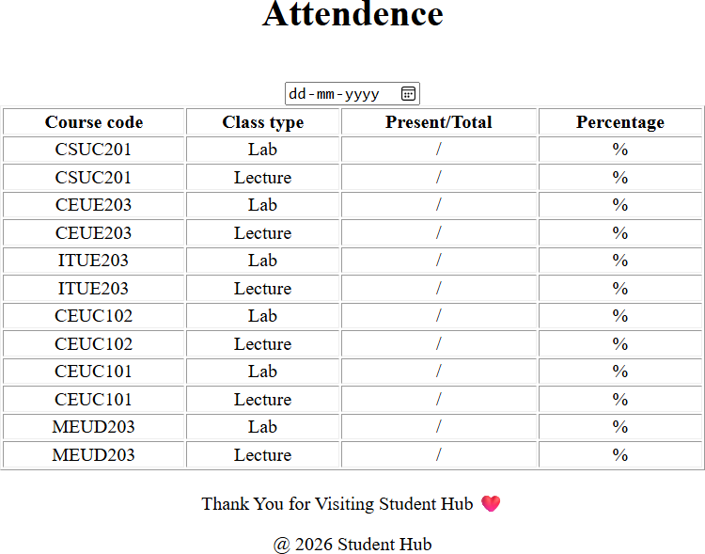

Contact.html
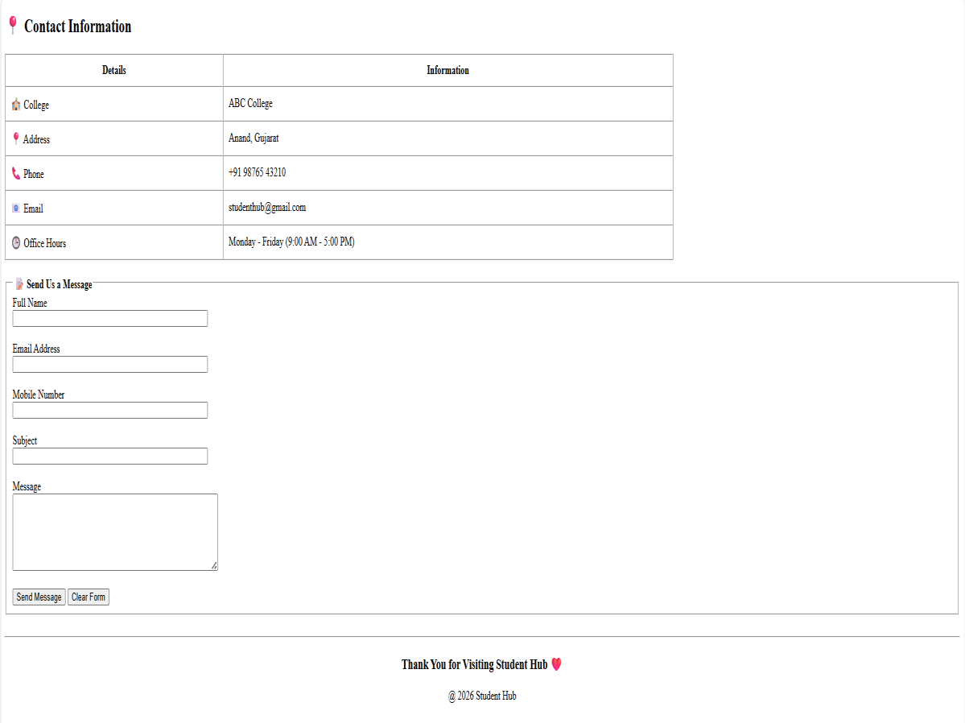

Profile.html

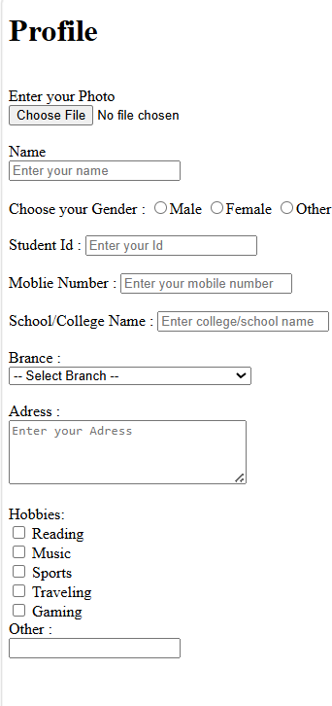

Result.html
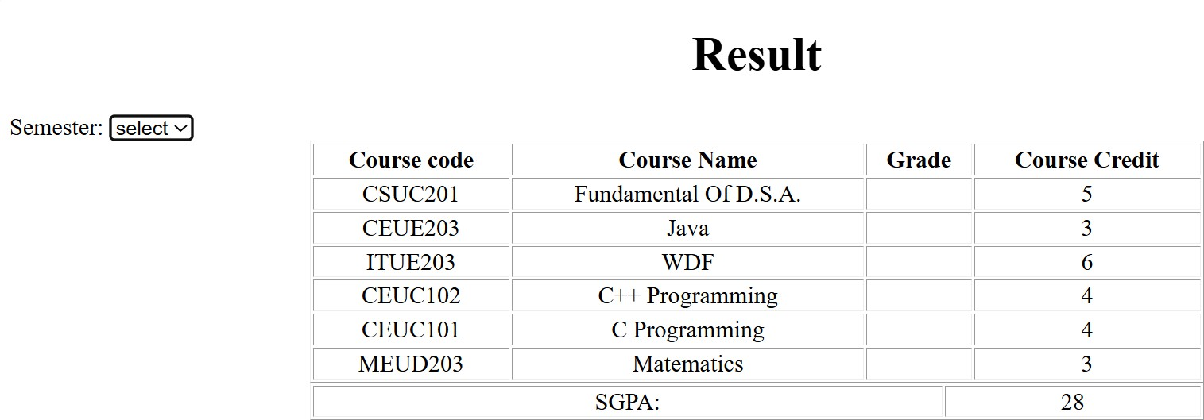

Registration.html
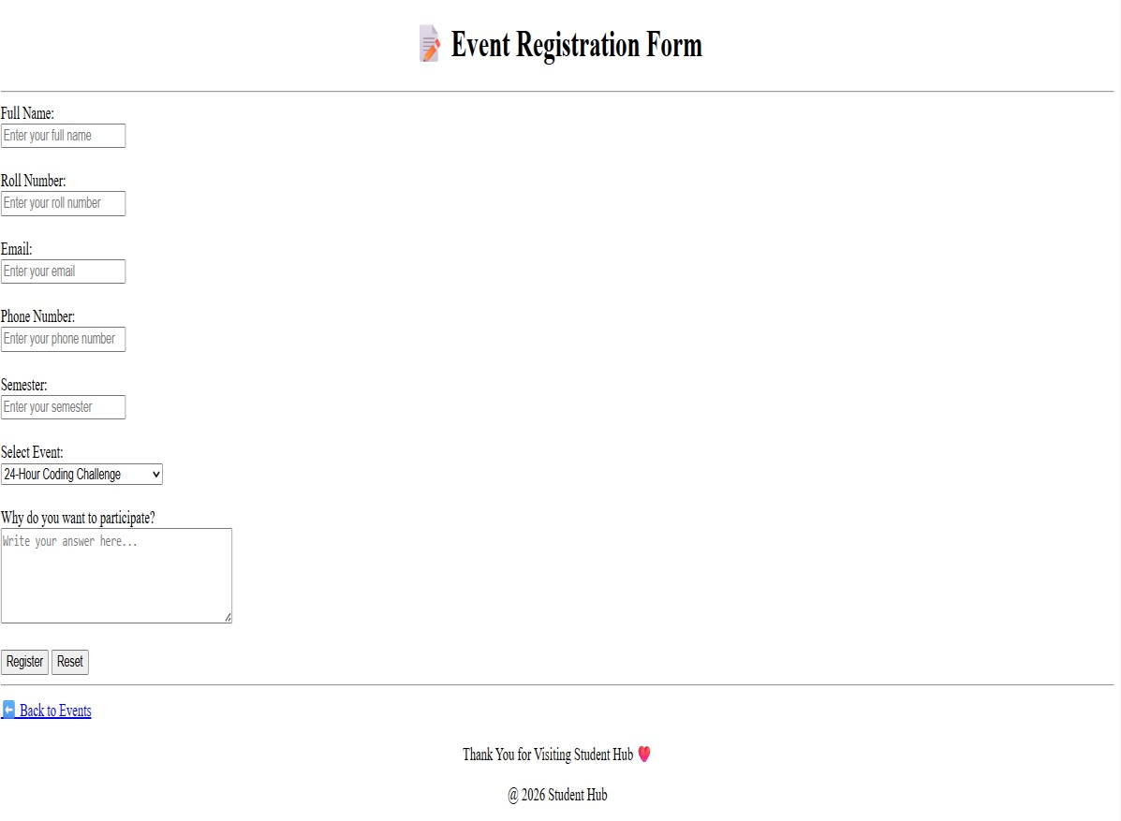

Course.html

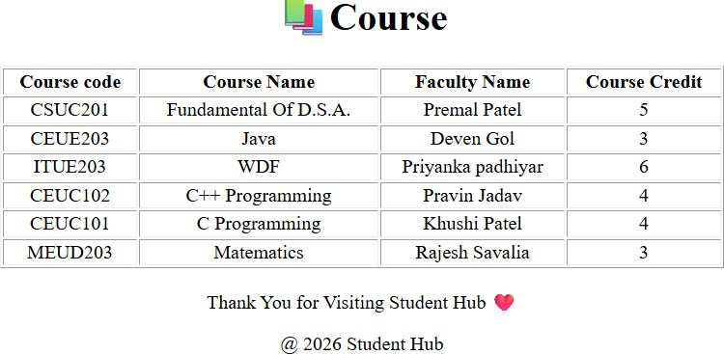

Assignment.html
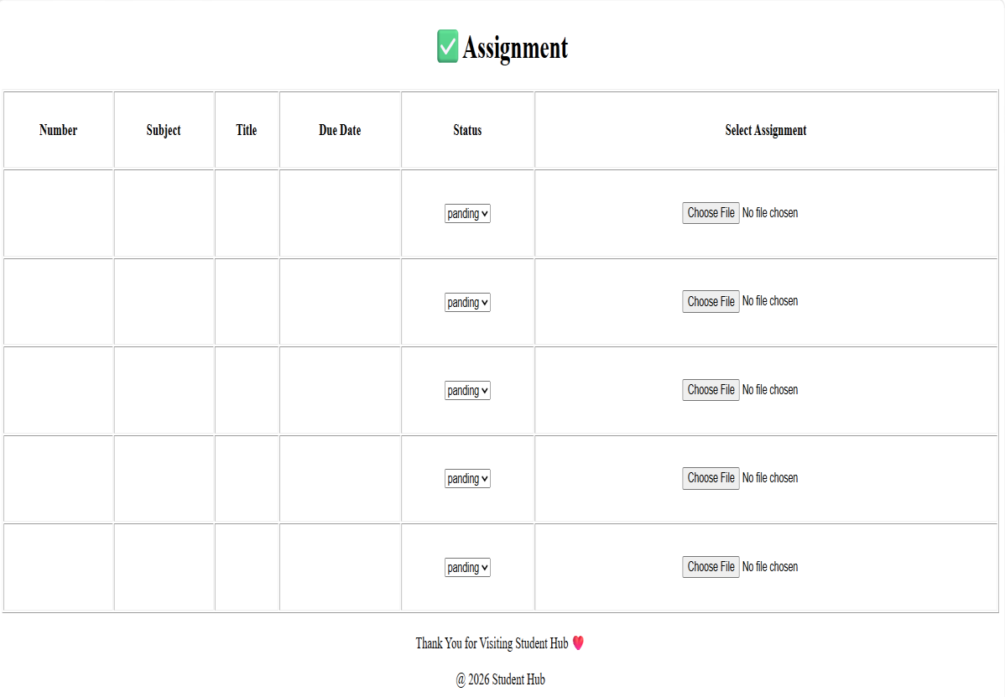

Event.html
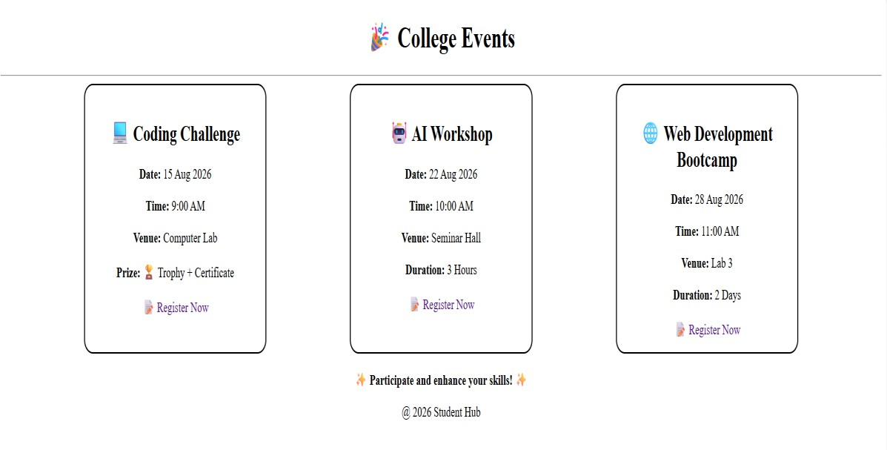

Setting.html
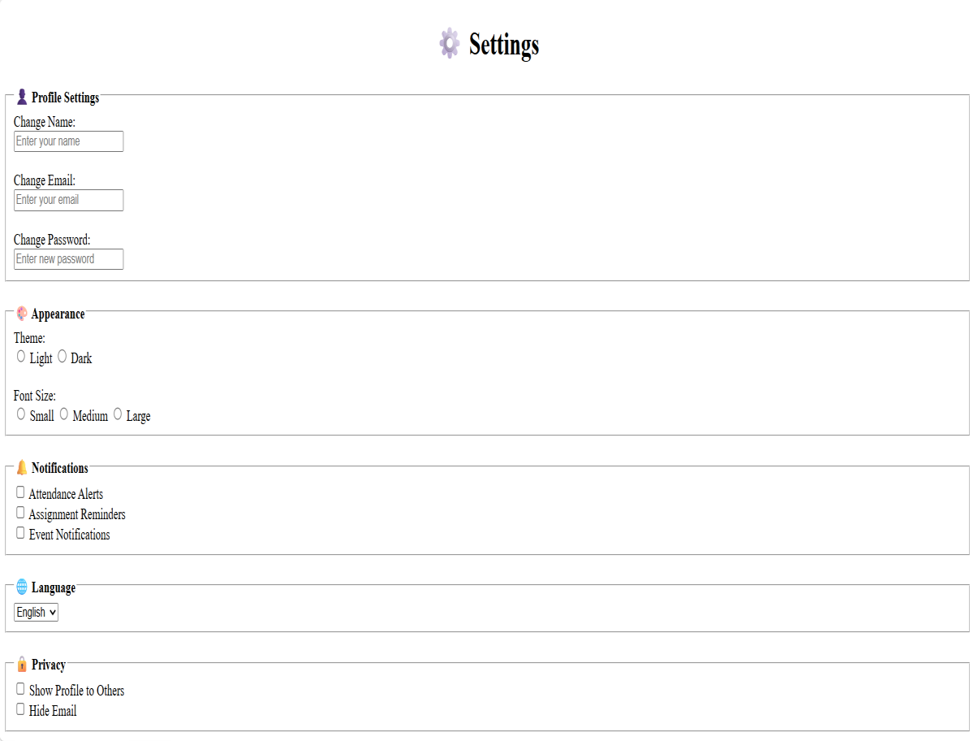

Feedback.html
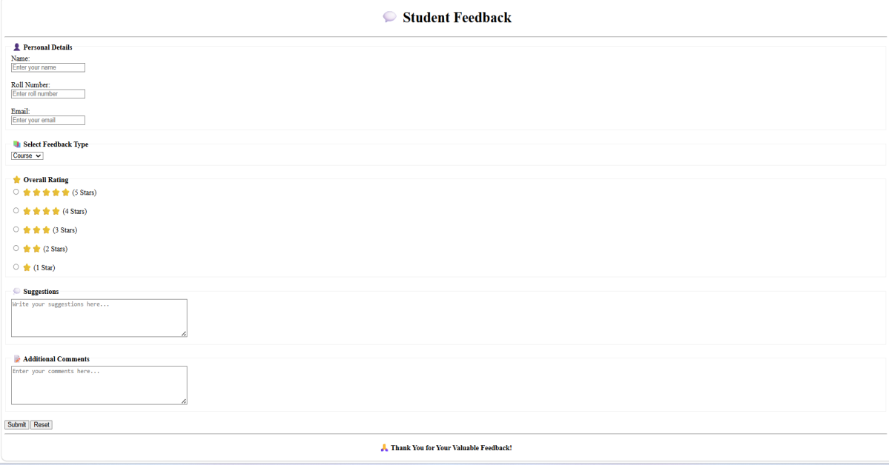

GitHub Repository Link:
https://github.com/AD-9218/Student-Hub

Challenges Faced:
I faced how to start first then how to navigation between all pages in web pages.Also do in all page navigation and proper order.

Learning Outcomes:
I learned how to create a consistent webpage layout and organize content properly. I also understood the importance of easy navigation and user-friendly website design.
Faculty Remarks:

